1. Introduction/hook:
   1. Vocal fry (a kind of creaky voice) has been the subject of numerous breathless stories in the popular media over the past few years
   2. [Cite examples here—Slate said x, WaPo said y, etc.]
   3. [Multiple studies have investigated creak in American English, LIST OTHER LANGUAGES]
   4. [ONE SENTENCE ABOUT PRACTICAL APPLICATIONS HERE]: naturalness of synthesized speech, study of pathological voice quality
   5. However, little to no research has been conducted on the status of phonation types in British English since the 1980s (Henton and Bladon 1985, 1988)
   6. Given the renewed media and scholarly attention on phonation types and their practical applications, a new, large-scale investigation of their status in modern British English is necessary
2. What phonation types are:
   1. Phonation types: different ways of producing sound through the vibration of the vocal cords (Keating and Esposito 2006: 85)
   2. Ladefoged saw phonation types as falling on a one-dimensional continuum based on the degree of glottal constriction: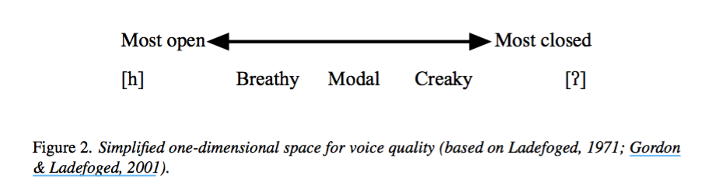
   3. This representation, while useful, is somewhat of an oversimplification:
      1. There are different ways of producing each of these phonation types, which can be measured different acoustic correlates (Keating and Esposito 2006:
      2. For instance, recent research (Garellek 2016; Kreiman 2014; Keating, Garellek, and Kreiman 2014) suggests that there are multiple types of creaky voice, which exist in a three-dimensional space: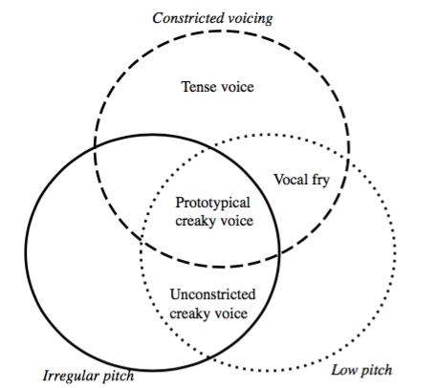
      3. Breathy voice can also result from various combinations of acoustic factors—such as glottal open quotient and harmonic-to-noise ratio—within and across languages (Keating and Esposito 2006: 86)
         1. [CITATION] shows that many of these acoustic contrasts are perceptible to native speakers
         2. However, there has not yet been a comprehensive attempt to
   4. Applications of the study of voice quality:
      1. Speech synthesis:
      2. Forensic speaker identification:
3. These phonation types and their acoustic correlates are:
   1. Breathy voice:
      1. Higher H1–H2, H2–H4, H4–H2 kHz, H2 kHz–H5 kHz Lower HNR (Garellek 2016: 21)
   2. Falsetto voice:
      1. Higher f0 (240 to 634 Hz in men, as compared to average of 100 Hz for modal voice) (Podesva 2007: 480)
   3. Prototypical creaky voice:
      1. Lower H1–H2 H2–H4, H4–H2 kHz, H2 kHz–H5 kHz Lower HNR (Garellek 2016: 21)
      2. Lower f0 (Garellek 2016: 21)
      3. Irregular f0 (Keating, Garellek, and Kreiman 2015: 3)
      4. /t/ glottalization vs phrasal creak: both are likely prototypically creaky (Garellek and Seyfarth 2016: 1057)
         1. /t/ Glottalization: primarily associated with noise (Garellek and Seyfarth 2016: 1057)
         2. Phrasal creak: primarily associated with f0 and spectral tilt (Garellek and Seyfarth 2016: 1057)
   4. Unconstricted creaky voice:
      1. Higher H1–H2 H2–H4, H4–H2 kHz, H2 kHz–H5 kHz Lower HNR (Garellek 2016: 21)
      2. Lower f0 (Garellek 2016: 21)
      3. Low HNR (Keating, Garellek, and Kreiman 2015: 3)
   5. Vocal fry:
      1. Lower H1–H2 H2–H4, H4–H2 kHz, H2 kHz–H5 kHz No difference in HNR (Garellek 2016: 21)
      2. BUT (Keating, Garellek, and Kreiman 2015: 3) says that this has high HNR values
      3. Lower f0 (Garellek 2016: 21)
      4. Low B1 values (Keating, Garellek, and Kreiman 2015: 3)
   6. Tense voice:
      1. Lower H1–H2 H2–H4, H4–H2 kHz, H2 kHz–H5 kHz No difference in HNR (Garellek 2016: 21)
      2. Higher f0 (Garellek 2016: 21)
   7. Multiply pulsed creak:
      1. High SHR (Keating, Garellek, and Kreiman 2015: 3)
      2. Low H1*-H2* (Keating, Garellek, and Kreiman 2015: 3)
      3. Low HNR (Keating, Garellek, and Kreiman 2015: 3)
   8. Aperiodic creak:
      1. Low HNR (Keating, Garellek, and Kreiman 2015: 3)
      2. Low H1*-H2* (Keating, Garellek, and Kreiman 2015: 3)
      3. Does NOT have low f0 (Keating, Garellek, and Kreiman 2015: 3)
4. Previous experimental and statistical methods that have been used to distinguish between these types of voice quality are:
   1. Statistical:
      1. ANOVAs to determine which measures are most important for distinguishing between different phonation types (Keating and Esposito 2006: 87)
      2. Linear discriminant analysis (Garellek and Seyfarth 2016, Keating and Esposito 2006: 87) and principal component analysis to distinguish between those measures (Keating and Esposito 2006: 87)
      3. t-tests (Yuasa 2010: 325)
   2. Experimental:
      1. Yuasa 2010:
         1. Spontaneous conversations about food, which the experimenter judged to be an “emotionally nonprovocative” topic (323)
         2. Randomly selected 401-word samples from each speaker, impressionistically coded occurrences of creaky voice, and then counted them (Yuasa 2010: 323-324)
      2. Garellek and Seyfarth 2016:
         1. Recordings of spontaneous speech taken from the Buckeye Corpus (1055)
         2. Creaky voice (/t/ glottalization and phrasal creak) identified using annotations in the corpus and manual inspection (1055)
         3. Excluded outliers with incorrect f0 tracking and standardized f0 (1055)
      3. Henton and Bladon 1988:
         1. FILL IN
      4. Henton and Bladon 1985:
         1. 36 Received Pronunciation speakers (20 females, 16 males), 25 Northern British English speakers (12 females and 13 males) from an existing database (223)
         2. Looked at
      5. Hanson et al. 2001:
         1. 21 male and 22 female subjects, each of whom recorded five tokens each of / {, V, E / in carrier phrases (461)
         2. Mean value for each acoustic measure calculated for each speaker (461)
         3. Also completed a perceptual experiment in which vowels from two speaker groups were created for breathiness
      6. Keating and Esposito 2006:
         1. Describes Esposito (2006), which was a perceptual study in which listeners sorted breathy and modal vowels based on perceived similarity and experimenters then determined which acoustic measures correlated with which categories (88)
5. Previous research suggests that sex, ethnicity, and SES may play a role in production of creaky voice:
   1. Sex:
      1. Women may produce breathier voice than men (Podesva and Callier 2015: 178, Henton and Bladon 1985: 221)  
         1. Simpson (2012) questions this
      2. Men may produce creakier voice than women, which could be due to their lower f0 (Podesva and Callier 2015: 178)
      3. Male speakers of RP may creak less than male speakers from northern England (?) (Podesva and Callier 2015: 178) (See Henton and Bladon 1988)
      4. Other gender differences in production of creaky voice include women in California and DC producing more creaky voice than males, Japanese women producing less creaky voice than American women, etc. (Podesva and Callier 2015: 178)
   2. Ethnicity:
      1. Previous studies have shown that listeners can distinguish white and African American speakers from speech alone, which may indicate that voice quality plays a role (Podesva and Callier 2015: 180)
      2. Nonmodal voice qualities used in some prototypically African-American stylized voices (Podesva and Callier 2015: 180)
   3. Sexual orientation:
      1. Falsetto phonation type associated with performance of gay identity (Podesva 2007: 481)
6. Gaps in the literature that we can address:
   1. Investigation of the status of voice quality specifically in British English:
      1. Last large-scale study was Henton and Bladon (1988)
   2. Investigations on large-scale corpora of subjects from different sexes, socioeconomic statuses, geographic locations, etc.:
      1. Previous investigations of voice quality have included relatively small samples, often of speakers of a specific dialect or from a particular area, e.g.:
      2. 40 adults from Ohio (Garellek and Seyfarth 2016: 1055)
      3. 22 adults (location and language unspecified) and 50 adults (native German speakers) (Simpson 2009: 1-2)
      4. 11 male and 12 female speakers of California English, all but two of whom were UC Berkeley graduate or undergraduate students (Yuasa 2010: 321), 10 female Japanese speakers (Yuasa 2010: 322)
      5. Even the largest studies had less than 100 participants, e.g. Henton and Bladon (1988)
   3. Large-scale validation of whether measures that have previously been used to distinguish between different phonation types

Papers that I don’t have access to:

* Gobl and Ni Chasaide 1992 (in Speech Communication): Acoustic characteristics of voice quality
  + http://idiscover.lib.cam.ac.uk/primo-explore/search?query=any,contains,%22Acoustic%20characteristics%20of%20voice%20quality%22&tab=default_tab&search_scope=default_scope&vid=44CAM_PROD&lang=en_US&offset=0
* Henton and Bladon 1988 (in Language, speech and mind. Studies in honour of Victoria A. Fromkin): Creak as a sociophonetic marker
* Henson and Blazon 1985 (in Language & Communication):
  + http://idiscover.lib.cam.ac.uk/primo-explore/search?query=any,contains,Breathiness%20in%20normal%20female%20speech:%20Inefficiency%20versus%20desirability&tab=default_tab&search_scope=default_scope&vid=44CAM_PROD&lang=en_US&offset=0